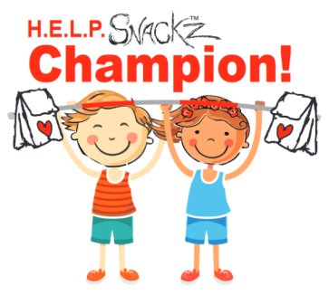
Homeless Engagement Lift Partnership is helping fill hunger gaps with daily afternoon nutritional snack bags called HELPSNACKZ. We Work with school districts and their Homeless Liaisons to identify which schools and students need our support. In the 2022/23 School Year, we will be delivering more than 26,000+ HELPSnackz a month. But, we can’t do it alone. We need your HELP!
Be a HELPSnackz Champion by hosting an event, people like you make this all a reality by helping us write and decorate these bags. We encourage you to invite friends, family, groups, neighborhoods, businesses, and organizations to get involved.
HELPSnackz Bagz is more than just a Snack, they have a Positive impact on these children.

Through hosting a Helpsnackz Champion event, you will be impacting so many lives by...
- Making a positive difference in children’s lives with decorated positive affirmations made with LOVE
- Bringing people together to give back to the community with their volunteer time with friends, family and meeting new people too
- You’re educating the need of helping the At-Risk Children in the community
- Sharing current H.E.L.P. Projects and Volunteer opportunities

Please follow these simple steps to ensure a successful event:
- Use/purchase Duro #4 Bags(White or Brown Bags ) (4-7/8 x 3" X 10") which can be purchased almost anywhere.
The biggest bang for your buck would be at Sam's Club or Costco.
- Choose a date and Invite, Invite
- Then, have your Guests decorate H.E.L.P.Bagz with powerful uplifting sayings (from the attached list), and your own beautiful artwork. Remember to HAVE FUN! You can use (markers, stickers, etc.) to design the bags.
Attached are the recommended sayings as well as some examples/ideas for the bags.
- After that, rubberband completed packs in groups of 40.
- Following the event, fill out your Drop Off Form and deliver completed bags to:
UPS Store (mention that you are dropping off for HELP)
Homeless Engagement Lift Partnership
610 E Bell #2-555
Phoenix, AZ 85022
OR NEW East Valley Location
Monday-Friday 11am - 6:30pm Saturdays 11am - 1pm
1420 East Chandler Boulevard Suite 104
Phoenix Arizona 85048
OR
H.E.L.P. Warehouse Tues and Thurs from 9:30 am to 12:00 pm
2727 W Sweetwater Phoenix, AZ 85029
To arrange other drop off times email Diane@helpingthehomelessnow.org
- Lastly, please fill out the attached H.E.L.P.Bagz Host form below and return it with your completed bags. Once dropped off, you can email Diane@helpingthehomelessnow.org to confirm.

Thank You and please feel free to contact me with any questions. Please reach out to us anytime!
Diane Verhoeven - Volunteer Coordinator for Help 602-628-4221

www.HelpingTheHomelessNow.org
Homeless Engagement Lift Partnership is a 501(c)3 corporation with the federal government and registered non-profit corporation in good standing with the Arizona Corporation Commission. Tax ID: 47-1110728 ​
Bringing Dignity & Hope to our Homeless Community
H.E.L.P.Bagz Host 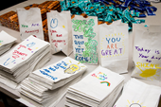
Please fill out the below form and return it to Diane@helpingthehomelessnow.org
Host Name:
Host Email:
Host Cell#:
Event Date:
Event Address:
Event Name/Organization/Group:
Goal - # of H.E.L.P.BAGZ to complete:
(for example if you have 25 people to complete 40 bags each your goal is 1,000 in 2 hours)
Notes:

www.HelpingTheHomelessNow.org

Homeless Engagement Lift Partnership is a 501(c)3 corporation with the federal government and registered non-profit corporation in good standing with the Arizona Corporation Commission. Tax ID: 47-1110728
​Bringing Dignity & Hope to our Homeless Community!

